SIMATS ENGINEERING
ASSESSMENT TOOL 2

COURSE NAME: CSA07 COURSE CODE: Computer Networks

COURSE OUTCOME COVERED

CO1: Apply the functions of OSI layer in enabling reliable data transmission across networks. (BL2, BL3)

Assessment Tool Weightage: 30%

Annexure A

CONCEPT MAPPING

1. A partially completed concept map is given below:

Application → Presentation → ______ → Transport → Network → ______ → Physical.
Analyze the missing layers and explain how their functions are essential for reliable communication.
The concept map represents the OSI (Open Systems Interconnection) Model, which has 7 layers:
Application → Presentation → Session → Transport → Network → Data Link → Physical
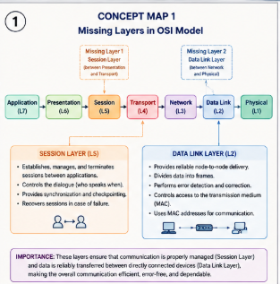
So, the missing layers are:
1. Session Layer – between Presentation and Transport
2. Data Link Layer – between Network and Physical
Functions of Missing Layers:
- Session Layer:
• Establishes, manages, and terminates communication sessions between devices.
• Controls the dialogue between applications.
• Provides synchronization and recovery during communication.
- Data Link Layer:
• Provides reliable node-to-node data transfer.
• Divides data into frames.
• Performs error detection and controls access to the transmission medium.
• Uses MAC addresses for communication within a network.
Importance for Reliable Communication:
The Session Layer ensures that communication between applications is properly maintained and synchronized, while the Data Link Layer ensures that data is transferred reliably between directly connected devices by detecting errors and organizing data into frames. Therefore, the complete OSI concept map is: Application → Presentation → Session → Transport → Network → Data Link → Physical Together, these layers ensure efficient, organized, and reliable end-to-end communication across a network.
2.Construct a concept map linking data units (Segment, Packet, Frame, Bits) with their respective OSI layers and analyze how transformation of data units supports transmission.
Analysis of Data Transformation:
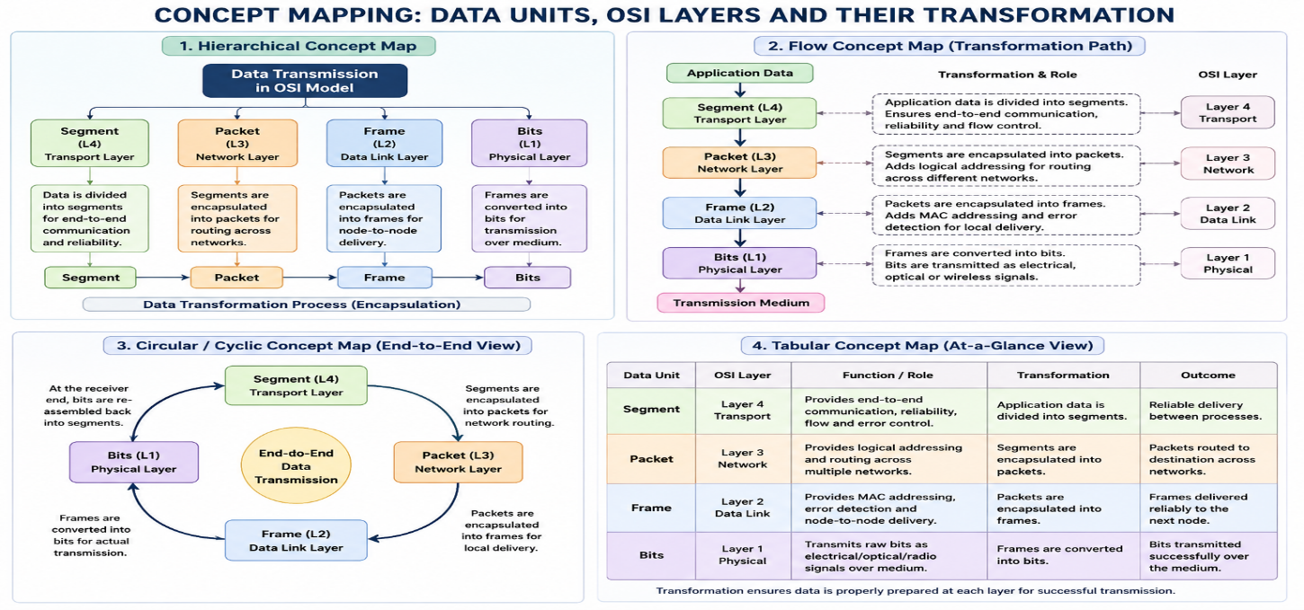

1. Transport Layer – Segment:
The data is divided into segments. Port numbers and sequencing information are added to support reliable end-to-end delivery.
2.Network Layer – Packet:
The segment is encapsulated into a packet. Logical addresses such as IP addresses are added to determine the source and destination.
3. Data Link Layer – Frame:
The packet is placed inside a frame. MAC addresses and error-detection information are added for reliable delivery between directly connected devices.
4. Physical Layer – Bits:
The frame is converted into a stream of 0s and 1s (bits) and transmitted through cables, fiber, or wireless signals
3.Given the concept map:
DataLink→MACAddress→LocalDelivery
Network → IP Address → Global Delivery
Explain how these relationships ensure complete data delivery across networks. 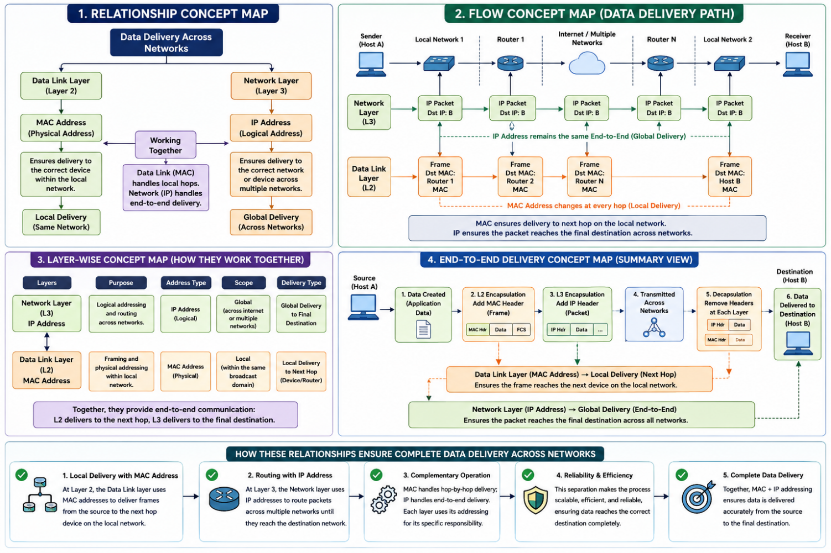
- Data Link Layer → MAC Address
o The Data Link Layer uses MAC addresses to identify devices within the same local network. o A MAC address uniquely identifies a network interface.
- MAC Address → Local Delivery
o MAC addresses are used to deliver frames from one device to another within the same Local Area Network (LAN).
o Switches use MAC addresses to forward frames to the correct device.
- Network Layer → IP Address
o When the destination is on another network, the Network Layer uses IP addresses to identify the source and destination networks.
o Routers examine IP addresses to determine the best path for the packet.

- IP Address → Global Delivery
o IP addresses enable packets to travel between different networks through routers. o This allows data to reach devices anywhere on interconnected networks, such as the Internet. Overall Relationship: Data → IP Address (Global Routing) → Router → MAC Address (Local Delivery) → Destination
4. A concept map shows:
ErrorControl
→DataLinkLayer→ErrorDetection
→ Transport Layer → Error Correction
Analyze how the interaction between these layers improves reliability in data transmission.

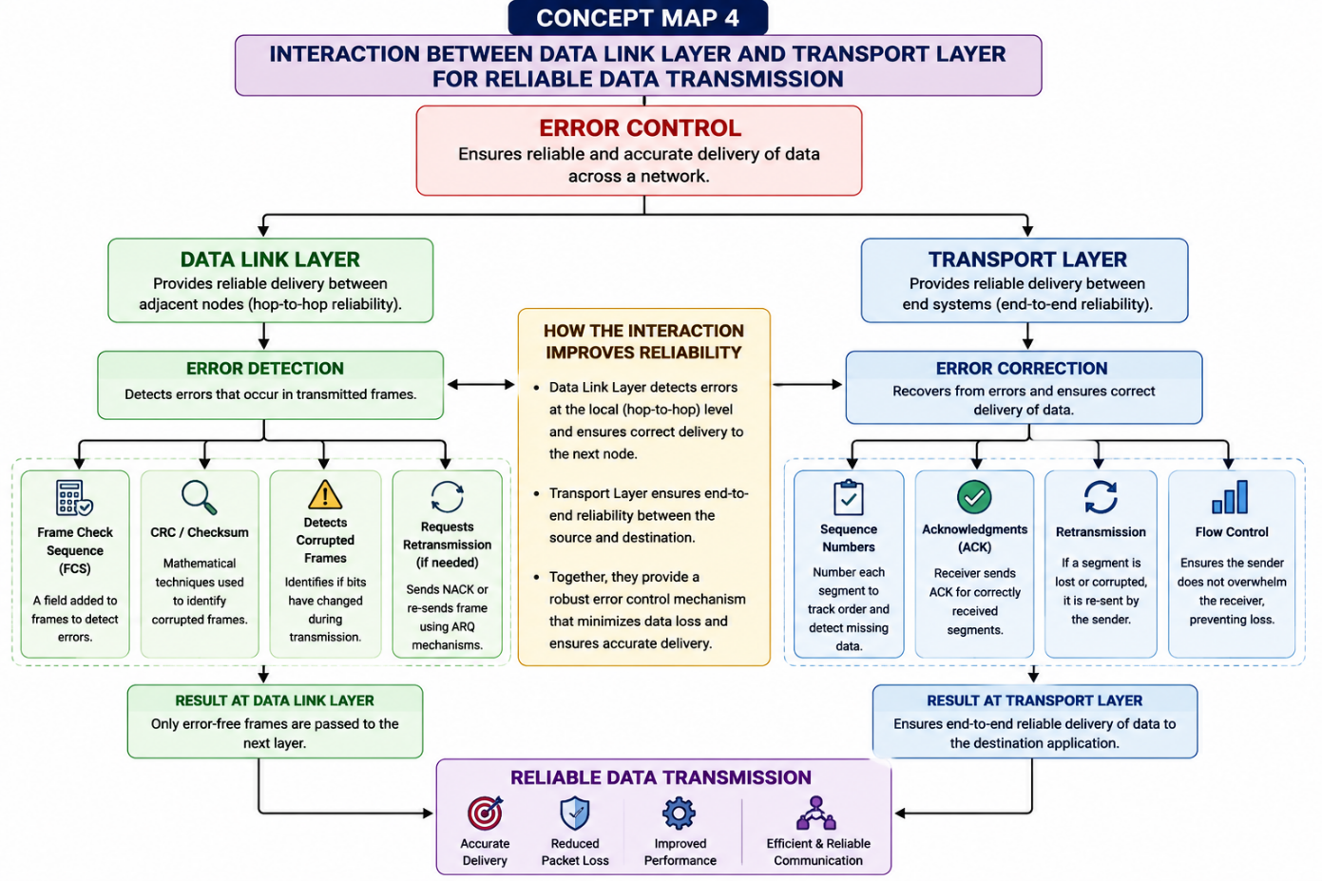

Step-by-Step Explanation:
- Error Control
o Error control is used to identify and handle errors that may occur during data transmission. o It helps ensure that the data received is accurate and complete.
- Data Link Layer → Error Detection
o The Data Link Layer detects errors that occur during node-to-node communication. o It uses techniques such as CRC (Cyclic Redundancy Check) to check whether a frame has been corrupted.
o If an error is detected, the damaged frame can be discarded or retransmitted.
- Transport Layer → Error Correction / Recovery
o The Transport Layer provides end-to-end reliability.
o Protocols such as TCP use acknowledgements, sequence numbers, and retransmission to ensure that missing or corrupted data is recovered.
o It ensures that data arrives at the destination in the correct order and without loss.
Interaction Between Layers:
Data Link Layer
→ Detects errors during local transmission
→ Prevents corrupted frames from moving forward
Transport Layer
→ Provides end-to-end error recovery
→ Retransmits lost or missing data
→ Ensures correct order and completeness
5. Develop a concept map for web browsing using OSI layers and analyze how failure in one layer affects the entire communication process.
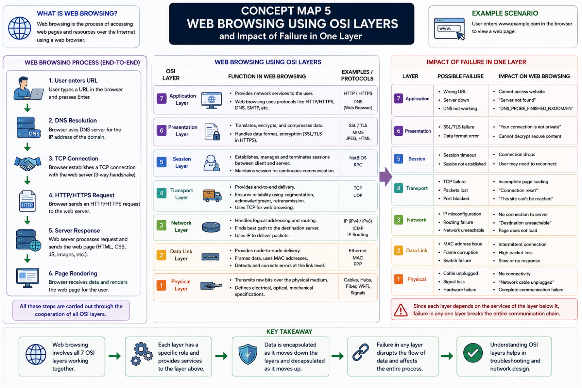

RUBRICS FOR CALCULATION

Criteria | Weightage (%) | Level 4 (Exemplary) | Level 3 (Proficient) | Level 2 (Developing) | Level 1 (Beginning)
Concept Identification | 20% | Accurately identifies all relevant OSI layers, concepts, and relationships | Identifies most concepts with minor omissions | Identifies limited concepts; some inaccuracies | Unable to identify key concepts correctly
Concept Mapping Structure | 25% | Constructs a clear, logical, and well-organized concept map with proper hierarchy and connections | Concept map is mostly clear with minor structural issues | Concept map lacks clarity, organization, or proper flow | No clear structure or incorrect mapping
Linking & Relationships | 20% | Clearly establishes correct relationships between layers, functions, and processes | Relationships are mostly correct with minor errors | Limited or partially correct relationships | Incorrect or missing relationships
Application & Analysis | 20% | Effectively applies concepts to explain processes (e.g., encapsulation, error control) with strong reasoning | The application is correct but lacks depth in analysis | Basic application with weak explanation | Unable to apply concepts correctly
Explanation & Clarity | 15% | Provides a clear, concise, and well-structured explanation supporting the concept map | Explanation is understandable with minor gaps | Explanation is unclear or incomplete | No clear or meaningful explanation

